Experiment :10 WAP to display pseudo Opcode & Location
counter for given assembly level code


Name : Kaladiya Ilaf Rollno : 16CO03
Class : TECO Batch : B 1

Source Code in python

import re
from prettytable import PrettyTable
t=PrettyTable(['SOURCE PROGRAM','First Pass','Second Pass'])
s_index=0
index=[]
index2=[]
newdata=[]
row2=[] row3=[]
fr=open("asm.txt","r")
data=fr.readlines()

for i in range(len(data)):
if 'START' in data[i]:
s_index=re.search("START+\s+[0-9]+",data[i])
if(s_index):
s_index=s_index.group(0)
s_index=re.search("[0-9]+",s_index)
s_index=s_index.group(0)
index.append(s_index)
newdata.append(data[i])
row2.append(str(s_index)+" ")
i+=1
else:
s_index=0
index.append(s_index)
newdata.append(data[i])
row2.append(str(s_index)+" ")
i+=1
if 'USING' in data[i]:
index.append(s_index)
row2.append(str(s_index)+" ")
newdata.append(data[i]+" ")
i+=1
line=re.search("[A-Z]+\s+[0-9]+,+[A-Z]+",data[i])
var=line.group(0)
s_var=re.search("[A-Z]{1,}",var)
s_var=s_var.group(0)
index.append(s_index)
newdata.append(data[i])
row2.append(str(s_index)+str(" "+s_var))
i+=1
j=i
for j in range(i,len(data)):
try:
line=re.search("[A-Z]+\s+[0-9]+,+[A-Z]+",data[j])
line2=re.search("[A-Z]+\s+([DC]+|[DS])+\s+(F+'[0-9]'+|[0-
9]+F)+",data[j])
if(line):
var=line.group(0)
s_var=re.search("[A-Z]{1,}",var)
s_var=s_var.group(0)
s_index+=4
index.append(s_index)
newdata.append(data[j])
row2.append(str(s_index)+str(" "+s_var))
j+=1
elif(line2):
get=line2.group(0)
getvalue=re.search("F+'[0-9]'",get)
if(getvalue):
getvalue=getvalue.group(0)
getvalue=re.search("[0-9]",getvalue)
getvalue=getvalue.group(0) getvalue=bin(int(getvalue))
s_index+=4
index.append(s_index)
newdata.append(data[j])
row2.append(str(s_index)+str("
")+str(getvalue).lstrip('0b'))
else:
s_index+=4
index.append(s_index)
newdata.append(data[j])
row2.append(str(s_index))

j+=1
else:
s_index+=4
index.append(s_index)
newdata.append(data[j])
row2.append(str(s_index))
j+=1
except:
pass
for i in range(len(newdata)):
if 'USING' in newdata[i]:
usval=re.search("[0-9]+",newdata[i])
usval=usval.group(0)
line3=re.search("[A-Z]+\s+[0-9]+,+[A-Z]+",newdata[i])
if(line3):
line3=line3.group(0)
s_var=re.search("[A-Z]{1,}",line3)
s_var=s_var.group(0)
var_label=re.search("[A-Z]{1,}$",line3)
var_label=var_label.group(0) for j in range(len(newdata)):
line4=re.search("[A-Z]+\s+([DC]+|[DS])+\s+(F+'[0-9]'+|[0-
9]+F)+",newdata[j])
if(line4):
line4=line4.group(0)
var_label2=re.search("[A-Z]{1,}",line4)
var_label2=var_label2.group(0)
if(var_label==var_label2):
row3.append(str(index[i])+str(" "+s_var+"
")+str("1,")+str(index[j])+str("(0,"+usval+")"))

else:
getvalue=re.search("F+'[0-9]'",newdata[i])
if(getvalue):
newgetvalue=getvalue.group(0)
if newgetvalue in newdata[i]:
getvalue=re.search("[0-9]",newgetvalue)
getvalue=getvalue.group(0) getvalue=bin(int(getvalue))
row3.append(str(index[i])+str(" ")+str(getvalue).lstrip('0b'))
i=+1
else:
row3.append(index[i])
for i in range(len(data)):
if 'END' in data[i]:
t.add_row([data[i],index[i],index[i]])
else:
t.add_row([newdata[i],row2[i],row3[i]])

t.align='c' print("\n")
print(t)

Output (Content of asm.txt)

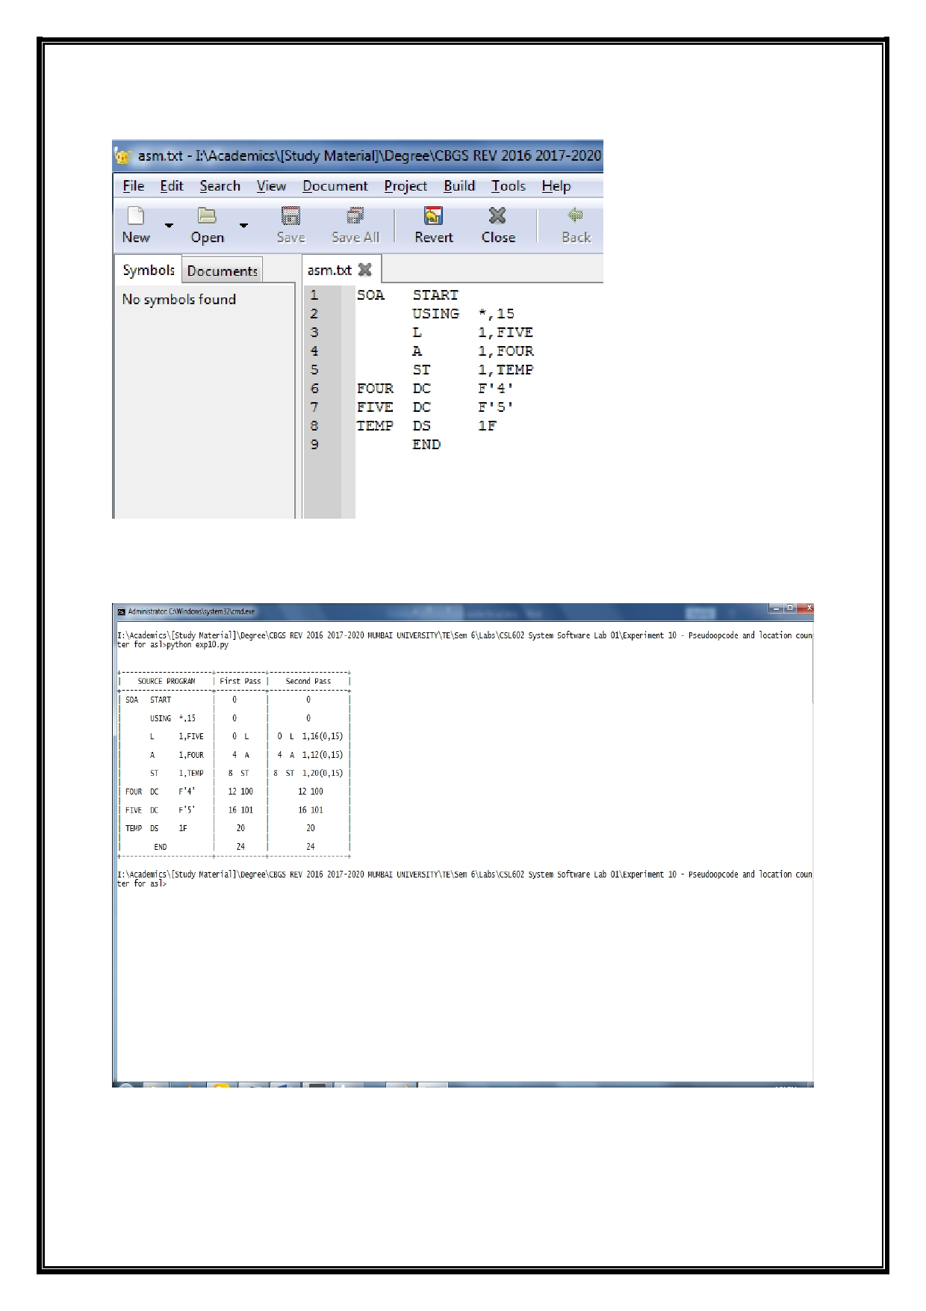
Output

